|  |  |  |
| --- | --- | --- |
|  | **T.C.**  **MANİSA CELAL BAYAR ÜNİVERSİTESİ**  **MÜHENDİSLİK FAKÜLTESİ**  **BİLGİSAYAR MÜHENDİSLİĞİ BÖLÜMÜ** |  |



**Tasarım Projesi / Lisans Bitirme Tezi**

**HAZIRLAYANLAR**

**ESMA ÇELİKTEN 160316043**

**FATMA KURTULUŞ 170316064**

**DANIŞMAN**

**ZEYNEP ÇİPİLOĞLU**

**MANİSA 2017**

**T.C.**

**MANİSA CELAL BAYAR ÜNİVERSİTESİ**

**MÜHENDİSLİK FAKÜLTESİ**

**BİLGİSAYAR MÜHENDİSLİĞİ BÖLÜMÜ**

**Tasarım Projesi / Lisans Bitirme Tezi**

**KABUL VE ONAY BELGESİ**

------------------------------------------------------------------------------------------------------------’ın “--------------------------------------------------------------------------------------------------------------” isimli lisans projesi çalışması, aşağıda oluşturulan jüri tarafından değerlendirilmiş ve kabul edilmiştir.

Danışman : ……………………………………………………..

Üye :

Üye :

Projenin Savunulduğu Tarih : ...........................................

Bilgisayar Mühendisliği Bölüm Başkanı

-------------------------------------------------



TABLO OF CONSTENTS

FIGURE LIST 4

A.INTRODUCTION 6

1.Hand drawing 7

2.Prototype 8

3.Login Page 10

4.Register Page 11

5. Profile Page 12

6. Application Template 16

7. Camera Page 16

a.Image to Text Converter Code 16

8.Home Page 18

9.Search Page 19

10.Library Page 20

11.Note page 21

12.Message page 21

B.SUMMARY 22

C. REFERENCES 22

D. ADDITION 24

1. Database Images 24

E. RESUME 29

1. Fatma Kurtuluş 29

2.ESMA ÇELİKTEN 31

# FIGURE LIST

Figure 1: Simple hand drawing for the application. 6

Figure 2 : Simple hand drawing for the application. 7

Figure 3: Login Page 7

Figure 4: Home Page 7

Figure 5: Profile Page 8

Figure 6: Search Page 8

Figure 7: Menu Page 8

Figure 8: Camera Page 8

Figure 9:Login page in Emulator. 9

Figure 101:This is Register page in emulation. 11

Figure 112:Profile page in emulation. 12

Figure 12: camera page work stages 16

Figure 13: Home page and sharing post 17

Figure 14: Search Page 18

Figure 15:Searching book 18

Figure 16: Book page 19

Figure 17:Book detail 19

Figure 18:Author page 19

Figure 19:Author detail 19

Figure 20: Notebook page 20

Figure 21:Message page 20

Figure 22:Authentication Database (Users register for this section.) 23

Figure 23:Realtime Database (BookList , Follow , Posts ,Users and AuthorList) 23

Figure 24:Realtime Database (BookList) Book information is kept in this section. 24

Figure 25: Realtime Database (BookList) Book information is kept in this section 24

Figure 26:Realtime Database (Follow) The uid information of the users following each other is kept in this section. 25

Figure 27:Realtime Database (Posts) Post information shared on the main page is kept in this section 25

Figure 28:Realtime Database (Users) Registered users name, email, profile photo and registration id are kept here.. 26

Figure 29:Realtime Database (AuthorsList) The author information that appears on the system is in this section. 26

Figure 30:Realtime Database (AuthorsList) The author information that appears on the system is in this section. 27

Figure 31:Cloud Firestore (Each note created through the system is recorded in a database called Notebook). 27

A.INTRODUCTION

A new book is released every day. Every day we want to buy and read new books. These books turn into stacks. Because new books are added every time. Our libraries in homes are getting complicated. What book was at home? We find it difficult to remember. We forget the number of our books. We decided to design this application to get rid of this complexity. All our books will be listed. Photographs of each book will be found. It is an application that I can access the tag of the book even if the book is not with me. Thus, the probability of buying two from a book is zeroed. The first reason for the emergence of this practice is to avoid buying more than one of the same books.

Before starting this project, we thought about what we can do and examined similar applications that were previously made. There are many web pages and applications related to the book in the market. Our goal is to design an application that will be enjoyed while using a more useful application . For this, we first created a simple hand drawing of how the application would look like and what pages could be (Figure1). Then using these hand drawings prototype application [17]. We reshaped it and the actual look of the application came out.

# 1.Hand drawing

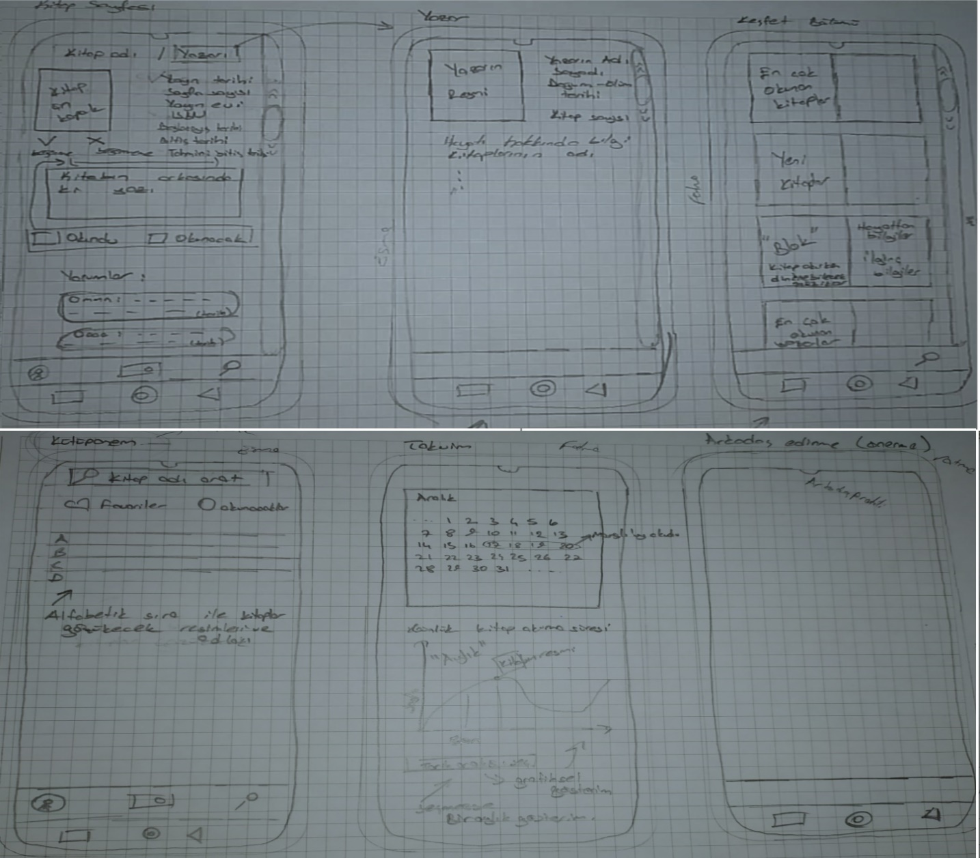

Figure 1: Simple hand drawing for the application.

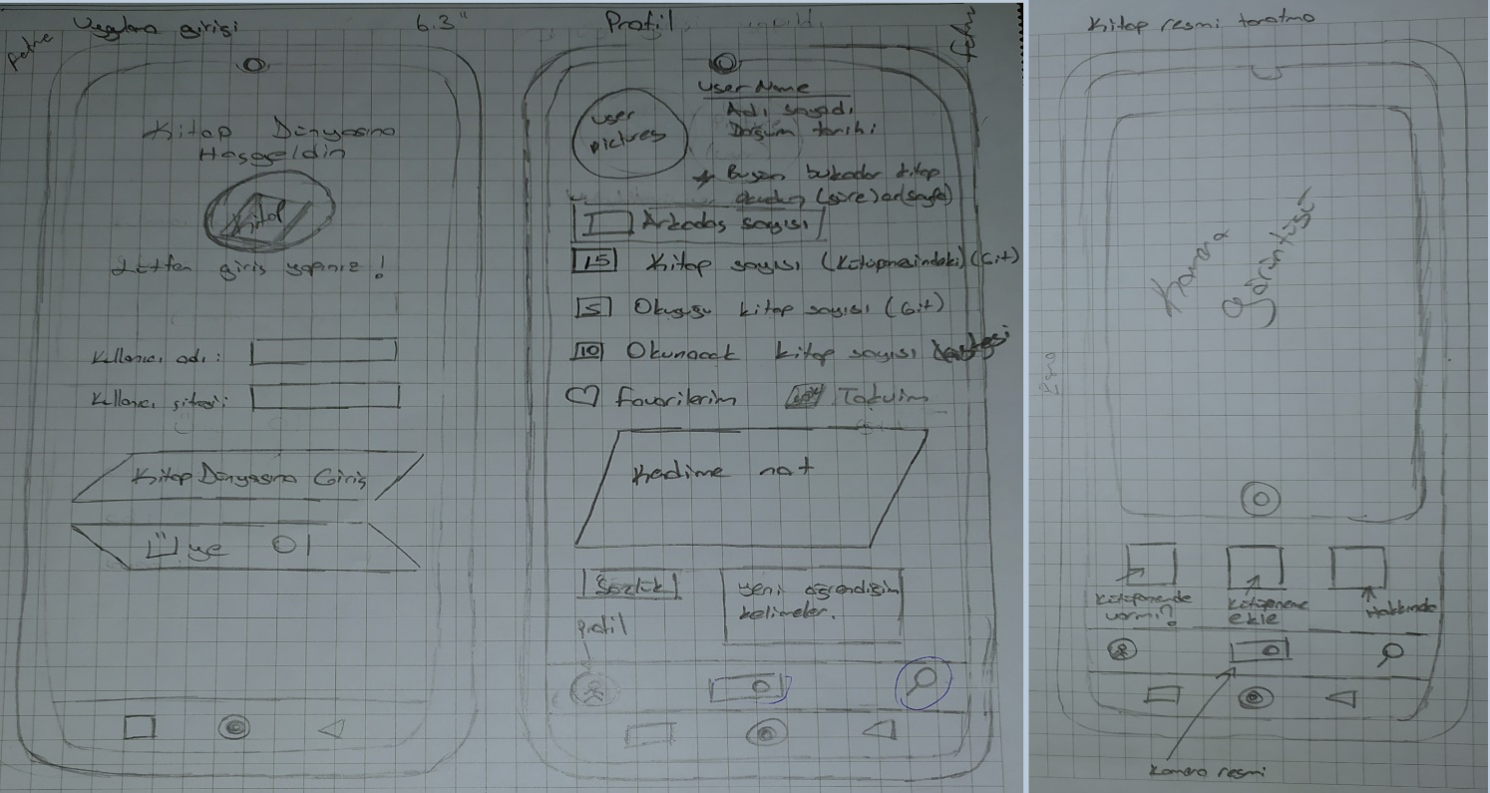

Figure 2 : Simple hand drawing for the application.

# 2.Prototype

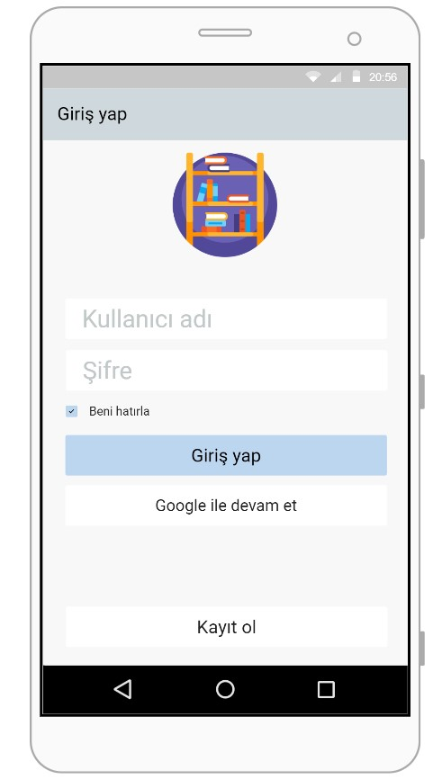

Figure 3: Login Page

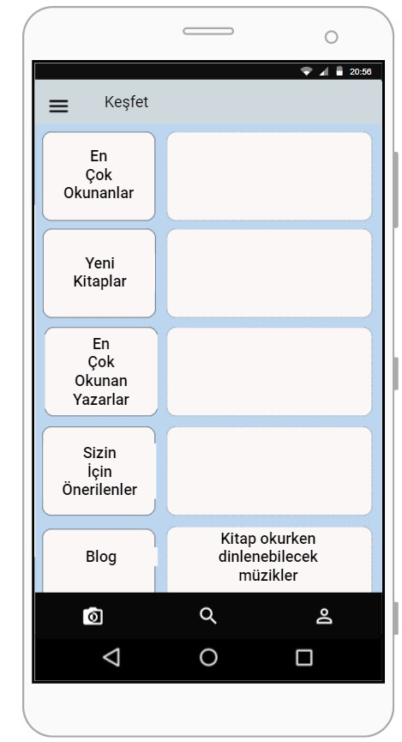

Figure 4: Home Page

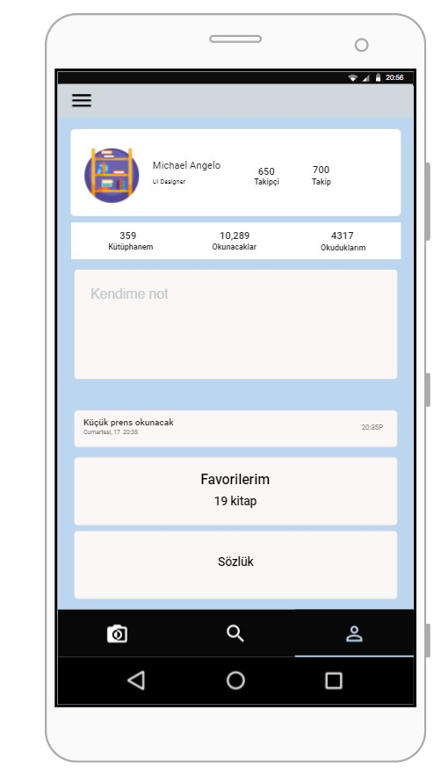

Figure 5: Profile Page

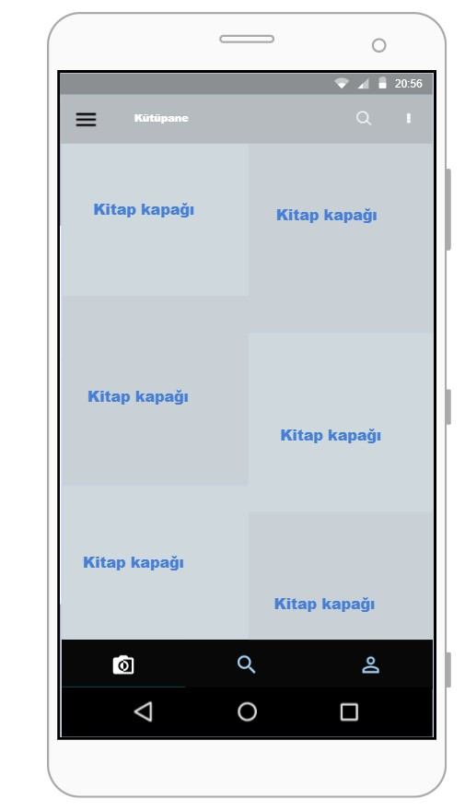

Figure 6: Search Page

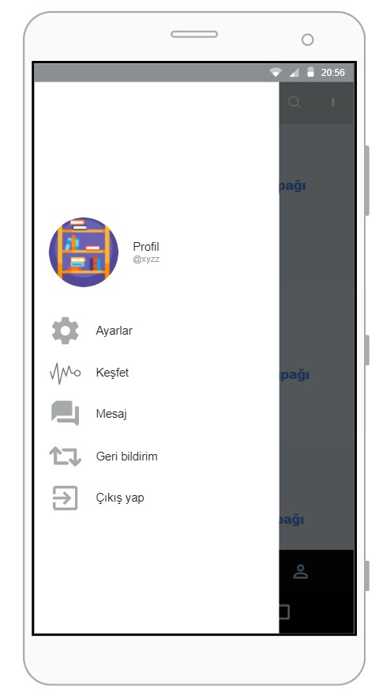

Figure 7: Menu Page

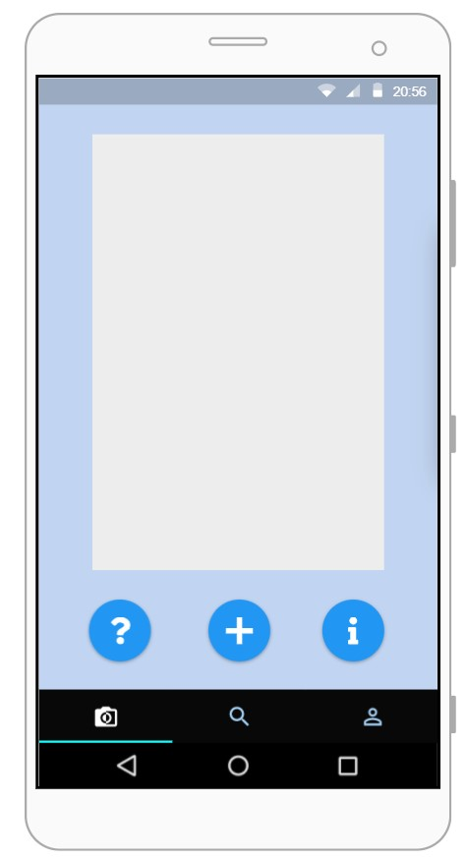

Figure 8: Camera Page

We have seen what we have to do with the prototypes we have created. We realized our shortcomings and made arrangements accordingly. The layout of our mobile application has been formed. After completing these steps, we switched to the coding phase. Using Android Studio, we started to create mobile application's pages and add functionality. We have determined the coding language we use in our application as JAVA. We started to create our application and made it possible with firebase to make management easier. We codified mobile application's each page step by step.

# 3.Login Page

The first page that will be presented to users when the application is first opened. The part where registered users can login to their own profiles. This page welcomes the users with a "Hoşgeldiniz" text. The picture that appears on the page is the logo and name we have chosen for our application. Registered users log in to the application by clicking the "Giriş Yap" button after entering their email and password information. The "Kayıt ol" button to the register page for non-registered users is on this page. With this button, you can switch to the registration page. The button seen at the bottom is the "Sing in" button that allows users to log in with their Google account. With this button, users can log into our application with their google account.

metin içeren bir resim

Açıklama otomatik olarak oluşturuldu

Figure 9:Login page in Emulator.

In case our registered users forget their password, "Şifrenizi mi unuttunuz?" clicks on the text. They write the email address they want to change the password for. With the “Email Gönder” button, we send a message to the email box of the account we wrote. The user can change his password by opening this page. If the user remembers the password, they can return to the login page with the "İptal" button.

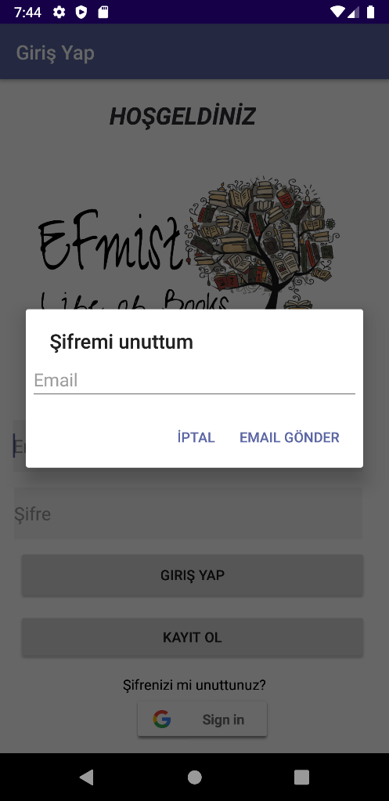

Figure10:Forgot password section in Emulator.

# 4.Register Page

Registration page for new users who are not registered on the application. When the information requested on this page is completed correctly, a profile page is created for the user. The logo of our application is also visible on this page. Four edit texts are defined in this section. These are top down; It is in the form of name, email, password, repeat password. Each regulation text must be filled in. If it is empty, an error message will appear. If the first edit text, namely the name edit text is empty, “Adınızı yazın!” (Write your name!) error message appears. The second edit text part is the part where the email should be written. The email address must be entered correctly in this section. In case of error, "Geçersiz Email !"(Invalid Email) error is received. The third part is the password part. Here, a minimum of 8 characters is specified to make the password difficult. It gives an error message in case of less input. This message is "Şİfre uzunluğu en az 8 karakter olmalıdır !"( Password length must be at least 8 characters!). The last edit text repeats the password that users created. This section is compared with the password written first. If the passwords are the same, the record is created. If different, “Şifre tekrarı aynı değil !” ( Password repeat is not the same!) gives the error message. After making sure that all edittexts are written correctly, they are saved to the related users database by clicking the "Kaydet"(Save) button. The application is entered into. When logging in, the information message that the user has been registered appears at the bottom.

If the user is registered, he / she can return to the login page by clicking the back icon in my top section or clicking the text "Kayıtlı mısınız? Giriş yap".

tablo içeren bir resim

Açıklama otomatik olarak oluşturuldu

Figure 101:This is Register page in emulation.

# 5. Profile Page

Each user must have their own profile. Each user should be able to see their own information. It should have access to its own library. On this page, users can access login information. Email and name information of logged in users can be seen here. When the logged-in user wants to log out, he / she can exit by pressing the three dots menu in the upper right corner. 

The people followed by the user and the people who follow the user can be reached. This information is accessed when the tracking and follower sections are pressed. 

Users can access their own library from this page. Under four separate categories, these are my books, my favorites, what I will readed and was read of book. In this section, the chapters of the book are defined as sliding. This is called Tablayout. We made each tab appear on the profile page. 

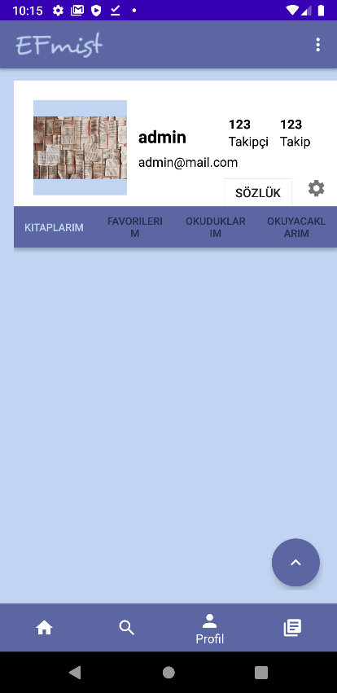

Figure 112:Profile page in emulation.

On this page, users can access their login information. This can change the information. The parts it can make changes are the user name and the profile picture. You can click the edit icon to access the part where it will make changes, or it will be enough to press the part you want to change. 

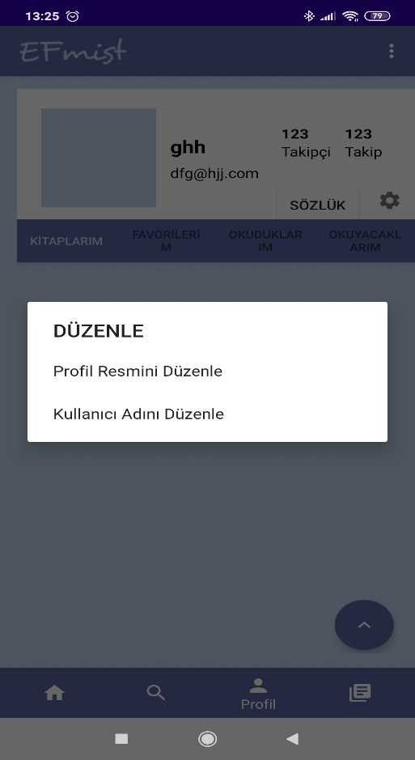

Figure13:User name and profile pictures edit in emulation.

After pressing the edit button, a box appears on the screen. We select the expression we want to edit. If he wants to change the username, the steps proceed as shown in Figure 14. The user changes the new name he wrote with the update button. If he doesn't want decides to change it, he can click the cancel button.

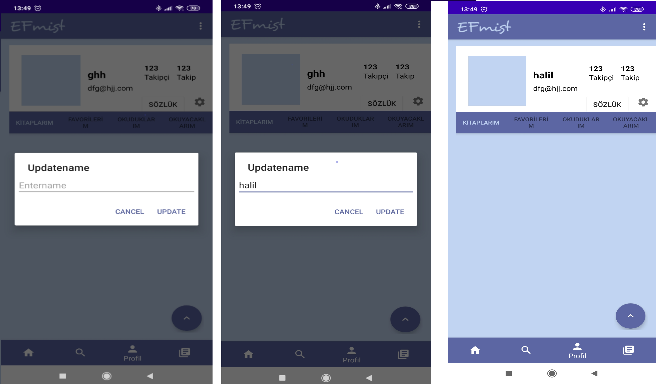

Figure14:User name edit in emulation.

Each changed information is changed on the realtime database (firebase web page).

Users can create a profile picture. They can take these photos either from the gallery or from the camera.

Another feature on the profile page is the dictionary button.  By clicking this button, users access the dictionary page of the Turkish Language Association (<https://sozluk.gov.tr/>). Using this page, users can learn new words. They can search for words that they don't know the meaning of here. Also, copy the new words they learned and paste them into the notes section. Can create his own dictionary.

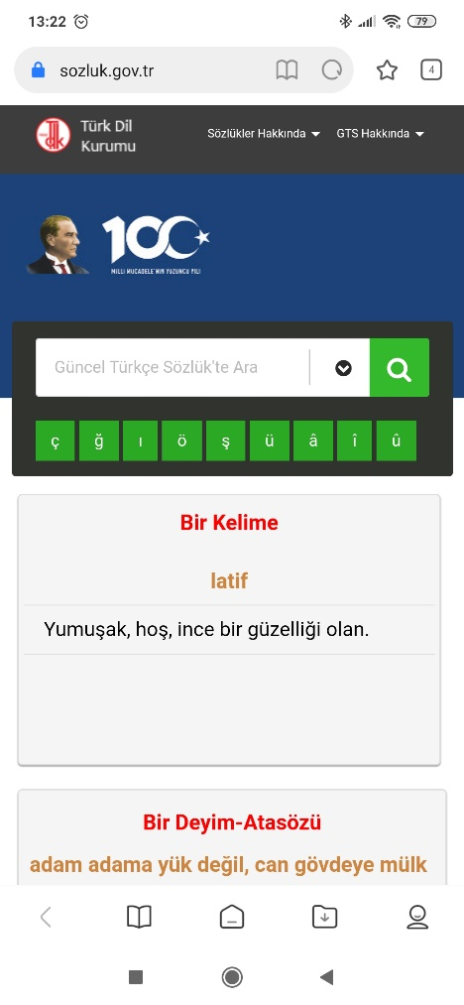

Figure15:Dictionary page in tdk.com

*.*

# 6. Application Template

In the sub menu, there are discover, search, profile and library icons. You can switch between pages by pressing these icons. With the buttons on the right, notes, camera and message can be accessed.

# 7. Camera Page

The camera page reads the text on the picture we take from the camera or the picture we choose from the gallery. It works fine only for languages with the Latin alphabet.

The working principle of this page;

First of all, we select our picture from gallery or camera by clicking the picture icon on the top right. The place to be turned into text is selected from the picture we chose. If desired, the picture can be rotated or reflected. After the picture is set, click the crop button and the desired place is converted to text.

The converted text can be added to notes by clicking on add to my notes if desired. I used the google library to convert from image to text. Below is shown step by step the above.

## a.Image to Text Converter Code

if (requestCode == CropImage.*CROP_IMAGE_ACTIVITY_REQUEST_CODE*) {  
 CropImage.ActivityResult result = CropImage.*getActivityResult*(data);  
 if (resultCode == *RESULT_OK*) {  
 Uri resultUri = result.getUri();  
 //set image  
 mPreviewIv.setImageURI(resultUri);  
  
 //get drawable bitmap for text  
 BitmapDrawable bitmapDrawable = (BitmapDrawable) mPreviewIv.getDrawable();  
 Bitmap bitmap = bitmapDrawable.getBitmap();  
  
 TextRecognizer recognizer = new TextRecognizer.Builder(getApplicationContext()).build();  
 if (!recognizer.isOperational()) {  
 Toast.*makeText*(this, "Error", Toast.*LENGTH_SHORT*).show();  
 } else {  
 Frame frame = new Frame.Builder().setBitmap(bitmap).build();  
 SparseArray<TextBlock> items = recognizer.detect(frame);  
 StringBuilder sb = new StringBuilder();  
 for (int i = 0; i < items.size(); i++) {  
 TextBlock myItem = items.valueAt(i);  
 sb.append(myItem.getValue());  
 sb.append("\n");  
 }  
 mResultEt.setText(sb.toString());  
  
 }  
 } else if (resultCode == CropImage.*CROP_IMAGE_ACTIVITY_RESULT_ERROR_CODE*) {  
 Exception error = result.getError();  
 Toast.*makeText*(this, "" + error, Toast.*LENGTH_SHORT*).show();  
 }  
}

Figure 12: camera page work stages

# 8.Home Page

You can read and share articles shared by others on this page. This page is not private, so everyone's posts appear on this page. To share a post, you can publish your post as a picture, title and description by pressing the pencil icon on the left.

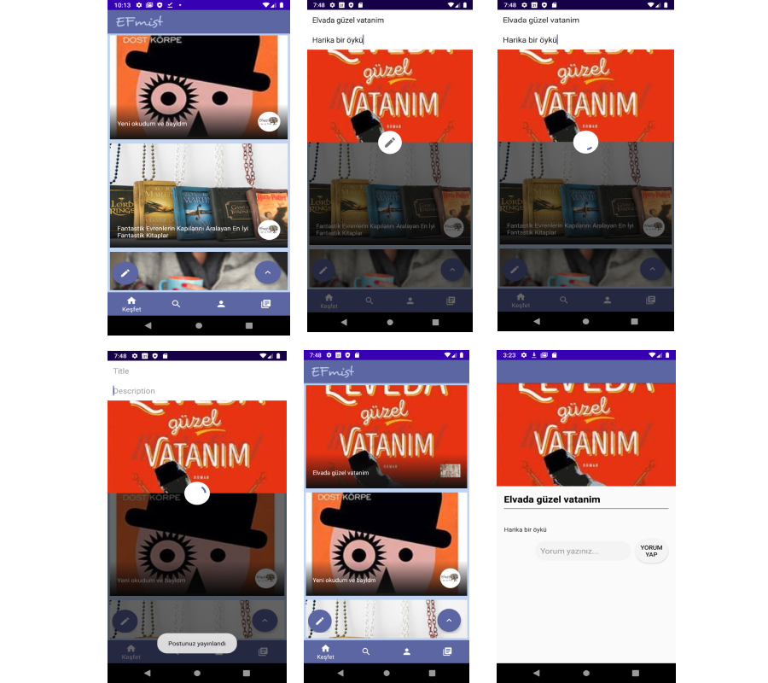

Figure 13: Home page and sharing post

# 9.Search Page

You can search for authors, books, and users on the Search page. You can follow desired users. All the information found here is kept in the firebase realtime database.

Figure 14: Search Page

Figure 15:Searching book

# 

# 10.Library Page

This page consists of two pages, books and authors. Books and authors are ordered from old to new. Short and general information can be accessed by clicking on the desired book or author.

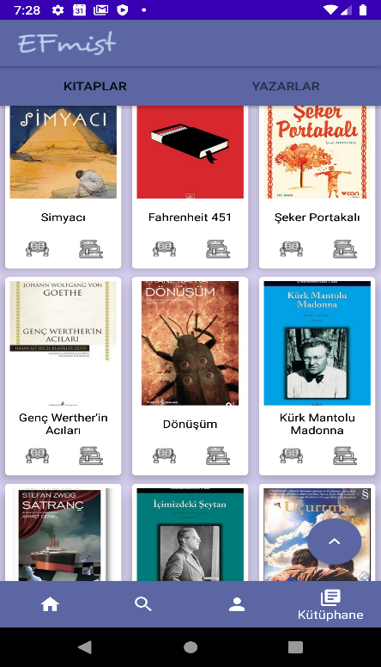

Figure 16: Book page

Figure 17:Book detail

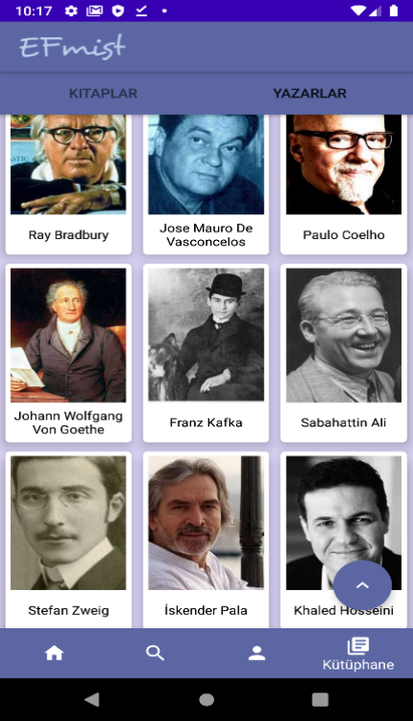

Figure 18:Author page

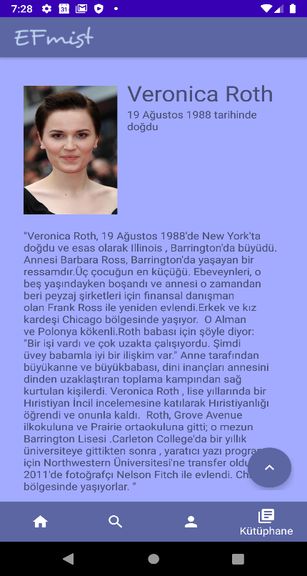

Figure 19:Author detail

# 11.Note page

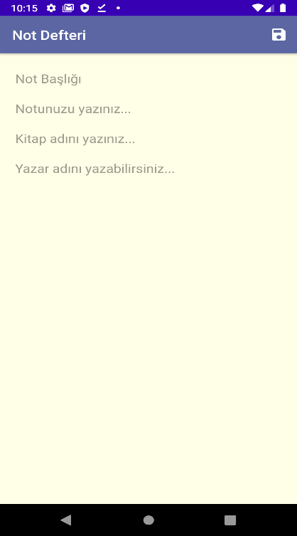

Your notes can be saved here. When you add a new note, the opened page consists of 4 parts: title, description, book title and author name. When you want to save a page from the book, you save it regularly using these chapters. It can also be used as a normal notebook. The texts from the camera are stored here. The database is stored with Firebase Cloud Firestore.

Figure 20: Notebook page

# 12.Message page

I can see the users I follow on the message page. The desired users would be able to send a message when clicked on the top, but this part could not be completed because the time was not enough.

Figure 21:Message page

B.SUMMARY

The application we have meets 70% of the application we originally designed. We wrote the parts that we think are important and run them. Design was left behind due to the code. We think that some parts of our application will be very useful. We had problems with internet speed. We think it's slow as we use the Firebase free plan. We think we can further improve the application we have.

# C. REFERENCES

1. Beyler A. (February 7, 2018) <https://www.mobilhanem.com/android-edittext-kullanimi/?__cf_chl_jschl_tk__=3eccfece16edb27f428a083d169a982c4e8087ab-1608215432-0-AWmkjUU0H7R68heB4rsaJ_OrQnUdISkXarcYnAe-yNaJ15tA26AMzFE2JdLnqsIXglOtiGR9y3KtyKujJGBHFW2p0Vw9FoJ2Bu3mxwoxoFWeK6WANxC5xUx_0OXOobE3qCWjUb73wXNcdznNbBePsT4uOc6m5Odi3xTtlk_vru-ql2bUQfCr1hOOkWrDBCmJhENK4C36TUexu4TvHgTQ76FRh55Xo9Y1a0nM7w9FdlVgvXKCMwRw0wsC4kB5OIpynkZtZRgs5Q3PJwshLqv4id-3F3hqg3Q555P3dij4YUYLbL77x0E0IoIqSIckEHoB4latSZ0p0QDIT77_uDhf3YI>
2. Biswas S. (November 1, 2019 ) <https://www.iditect.com/how-to/58654144.html>
3. Çakır M.B. (August 14 , 2019) <https://medium.com/android-t%C3%BCrkiye/etkili-layout-se%C3%A7imi-ve-kullan%C4%B1m%C4%B1-a2cf833ac85d>
4. Ersoy M. (October 31,2018) <https://medium.com/kodcular/android-firebase-ile-%C3%BCye-giri%C5%9Fi-7d6968f72be0>
5. Firebase app install and manage page <https://console.firebase.google.com/>
6. Google (December 27 , 2019) <https://developer.android.com/reference/com/google/android/play/core/tasks/Task>
7. Google (October 19,2020 ) <https://firebase.google.com/docs/auth/android/password-auth>
8. <https://www.11zon.com/zon/android/how-to-show-error-message-below-edittext-in-android.php>
9. Mıhçı G. (March 29 , 2016) <https://journo.com.tr/6-adimda-mobil-uygulama-arayuzu-tasarimi>
10. Onur U. (January 28 , 2017)<http://umutonur.com/firebase-ile-login-veri-tabani-islemleri-android/>
11. Pithwa H. (September 18, 2020)<https://uniqueandrocode.com/login-and-registration-form-in-android-studio-code/>
12. Prototyping page proto.io
13. Stern S. <https://github.com/firebase/quickstart-android/blob/11386852e861e6bfa17dd2fd80172f1b00e1fc4e/auth/app/src/main/java/com/google/firebase/quickstart/auth/java/EmailPasswordActivity.java#L70-L76>
14. Storage of data <https://console.firebase.google.com/project/gprojem-11d40/firestore/rules>
15. User registration and login information <https://console.firebase.google.com/project/gprojem-11d40/authentication/users>
16. Yaşar M. İ. (Desember 4,2018) <https://medium.com/gisera/s%C4%B1f%C4%B1rdan-mobil-uygulama-geli%C5%9Ftirmek-8bcf2c6d4384>
17. Yılmaz S. (October 18, 2016) <https://medium.com/@sinanyilmaz/android-firebase-authentication-email-parola-ve-google-cc154d1bf5fe>
18. **Hub, Arthur.**

*https://github.com/ArthurHub/Android-Image-Cropper.*

1. **Google firebase.**

https://developers.google.com/android/guides/releases

1. **Google firebase.**

https://firebase.google.com/docs/storage/android/start

1. **Google firebase.**

https://firebase.google.com/docs/database

1. **Educatreee.**

https://educatree.blogspot.com/2019/08/upload-image-with-text-to-firebase.html

1. **Google firebase.**

https://firebase.google.com/docs/ml/android/recognize-text

1. **Atif Pervaiz**

https://atifsoftwares.blogspot.com/

1. The page where the dictionary button goes

https://sozluk.gov.tr/

D. ADDITION

Screen shots videos showing the program's actions on the emulator.

<https://drive.google.com/file/d/14lF8SgJy44uNhkhMMBStydKSelVnNEsH/view?usp=sharing>

Videos can be accessed via MyDriver. The screenshots taken in the program and the database images used can also be accessed via this link.

# 1. Database Images

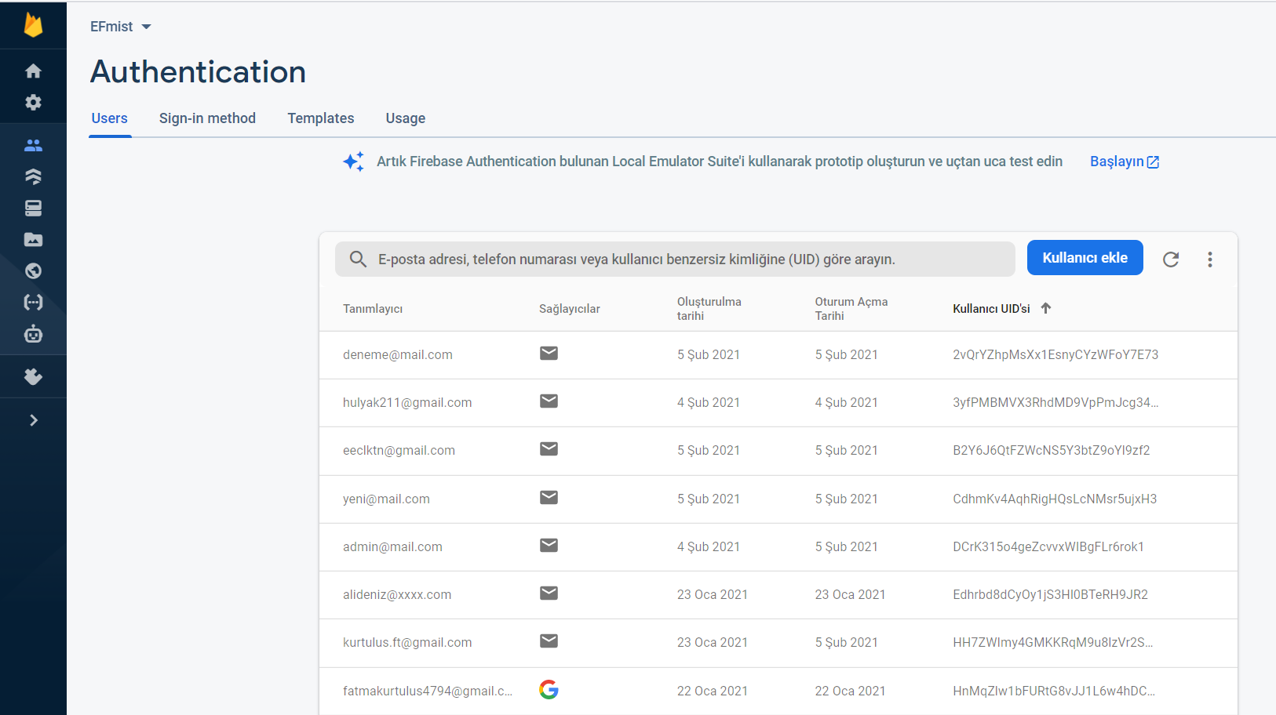

Figure 22:Authentication Database (Users register for this section.)

metin içeren bir resim

Açıklama otomatik olarak oluşturuldu

Figure 23:Realtime Database (BookList , Follow , Posts ,Users and AuthorList)

metin içeren bir resim

Açıklama otomatik olarak oluşturuldu

Figure 24:Realtime Database (BookList) Book information is kept in this section.

metin içeren bir resim

Açıklama otomatik olarak oluşturuldu

Figure 25: Realtime Database (BookList) Book information is kept in this section

metin içeren bir resim

Açıklama otomatik olarak oluşturuldu

Figure 26:Realtime Database (Follow) The uid information of the users following each other is kept in this section.

tablo içeren bir resim

Açıklama otomatik olarak oluşturuldu

Figure 27:Realtime Database (Posts) Post information shared on the main page is kept in this section

tablo içeren bir resim

Açıklama otomatik olarak oluşturuldu

Figure 28:Realtime Database (Users) Registered users name, email, profile photo and registration id are kept here..

tablo içeren bir resim

Açıklama otomatik olarak oluşturuldu

Figure 29:Realtime Database (AuthorsList) The author information that appears on the system is in this section.

metin içeren bir resim

Açıklama otomatik olarak oluşturuldu

Figure 30:Realtime Database (AuthorsList) The author information that appears on the system is in this section.

metin içeren bir resim

Açıklama otomatik olarak oluşturuldu

Figure 31:Cloud Firestore (Each note created through the system is recorded in a database called Notebook).

E. RESUME

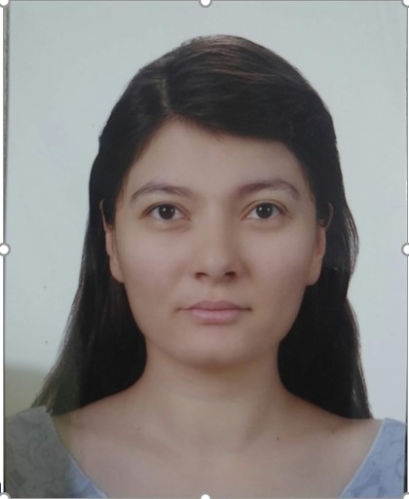

# 1. Fatma Kurtuluş

[kurtuluş.ft@gmail.com](mailto:kurtuluş.ft@gmail.com)

B driver license

**Education**

2017 – Bachelor degree(4. sınıf)

Manisa Celal Bayar University, Computer Engineering Department 2.8/4

2012-2014 Associate Degree

Manisa Celal Bayar University, Department of Computer Programming 3/4

2009-2012 High school

İmkb Anatolian Vocational High School, İzmir 78/100

**Events, Certificates, Scholarships and Awards**

|  |  |  |
| --- | --- | --- |
| 2018 |  | Cyberege '18 (Conferences and Courses) |
|  |  | Industry 4.0 (Conferences) |
| 2019  2020 |  | Basic electronics training (Odtü metü bilgeis.net C.codes: 0d774a80-b5c5-11e8-a374-69027da44d1c)  Kali linux tutorial (MCBU BİLİŞİM)  WordPress education (WPOKULU)  QNB Finansbank Career  Manisa Industrial Park Hackathon  SALES & MARKETING Digital Talent Summit  Paragliding Certificate (P2)(by THY- C.N:11705)  Seo Education (C.n: 261203860004 by iienstitu.com)  Social Media Expertise Training (S.n: 100110520021by iienstitu.com)   |  |  | | --- | --- | |  | Sign Language Education (S.n: 100110230125 by iienstitu.com for turkish) | |

**Internship experience**

Summer 2014 Intern NSGrup Web Design Software

2011 – 2012 IT Intern İndeks A.Ş

Summer 2019 IT Intern M.C.B.U Hospital

**Areas of interest**

Web Programming, Artificial Intelligence, Android

**Programming Languages Known**

C, C#, Java, SQL, Python, Android Studio, Firebase, Asp.net

**Vehicles used**

Visual Studio, Android Studio, MS Access, WampServer, Adobe Photoshop

**Projects, Theses**

Projects Title: Cinema Ticket automation

Summary: Issuing tickets and choosing locations for Movie Theaters

Title: Film and Cinema website

Summary: Housing Movie Theaters and Films

Title: 2 bit calculator

Summary: Addition, multiplication, subtraction, comparison in 2-bit numbers using

electronic circuits

Title: Catering System

Title: Phonebook

Title: Find weather

[akina44 / Repositories · GitHub](https://github.com/akina44?tab=repositories)

**Foreign language**

English (university preparatory score: 66 (2017))